Agri-AI

**Team Id:**

CU_CP_601

**Team member name:**

1.Aesha Shah

2.Rahul Pahelani

3.Bhaktil Chauhan

INDEX

|  |  |  |
| --- | --- | --- |
| Sr no. | Description | Page no. |
| 1 | Abstract | 3 |
| 2 | Problem Statement | 4 |
| 3 | Introduction | 5 |
| 4 | Key Features | 6 |
| 5 | End User | 7 |
| 6 | Diagram | 8 |
| 7 | Project-Screenshot | 9 |
| 8 | Conclusion | 13 |

**1.Abstract**

**AgriAI - Transforming Agriculture through Smart Technology**

* As the global population continues to grow, the need for sustainable and efficient agriculture becomes increasingly critical. AgriAI, a cutting-edge AI/ML project, aims to revolutionize traditional farming practices by seamlessly integrating advanced technologies. The project addresses challenges such as unpredictable crop yields, inefficient fertilizer utilization, and the timely identification of crop diseases that hinder productivity and sustainability in agriculture.
* AgriAI's key features include predictive analytics, machine learning algorithms, and image recognition. By analyzing historical and real-time data, the platform accurately forecasts crop yields, enabling farmers to plan efficiently and make informed decisions aligned with market trends. Personalized fertilizer suggestions optimize resource utilization, reducing waste and environmental impact. The incorporation of image recognition technology facilitates rapid and visual crop disease identification, allowing farmers to proactively manage risks and protect their harvests.
* The project's impact extends beyond individual farms, reaching agricultural extension services, agribusinesses, government agencies, researchers, and environmental organizations. AgriAI emerges as a beacon of innovation, fostering resilience, maximizing productivity, and promoting sustainable practices. This project signifies a pivotal step toward a more efficient, informed, and eco-friendly future in agriculture, emphasizing the harmonious coexistence of technology and nature for global food security.

**2.Problem Statement**

* Farmers face challenges in growing crops because they can't predict how much they'll produce, use fertilizers efficiently, or quickly deal with crop diseases. This leads to lower crop yields, wasting resources, and making crops more vulnerable to problems.
* To solve these problems, we need a smart project called AgriAI that uses advanced technology (like artificial intelligence and machine learning). Right now, farmers don't have good enough tools to make smart decisions. AgriAI wants to change that by giving farmers easy-to-use tools to predict crop yields, get personalized advice on using fertilizers, and quickly identify and fix crop diseases.
* Imagine if farmers could always know how much they'll harvest, use just the right amount of fertilizers, and stop crop diseases before they spread. That's what AgriAI aims to do – help farmers make better decisions, grow more food, and take care of the environment for the future.

**3.Introduction**

* In the world of farming, where it's important to grow more food while taking care of the environment, AgriAI is like a game-changer. Farming isn't easy because sometimes farmers don't know how much food they'll get, or they use too much fertilizer, or their crops get sick. These problems affect not only the farmers but also the food we all eat. AgriAI is like a smart computer program that helps farmers make better choices using fancy technology like computers and smart learning.
* AgriAI works by using computers to look at lots of information about farms, like the weather and the soil. It helps farmers predict how much food they'll get, so they can plan better. It also tells them exactly how much fertilizer to use, so they don't waste it or harm the environment. And if a crop gets sick, AgriAI can even recognize the problem quickly and help the farmer fix it before it gets worse.
* AgriAI isn't just a regular program; it's like having a super-smart helper on the farm. It's here to make farming easier and better for everyone. With AgriAI, farmers can grow more food, use fewer resources, and keep our food supply safe and healthy. It's like bringing the future to the farm, and it's making a big difference in how we grow our food.

* **Key Features :**

1. Crop Prediction
2. Fertilizer Suggestions
3. Crop Disease Identification

**4.Key Features**

1. **Crop Prediction:**

AgriAI utilizes predictive analytics to forecast crop yields accurately. By analyzing historical and real-time data, including weather patterns and soil health, the platform enables farmers to plan planting schedules, manage resources effectively, and make informed decisions based on market trends.

1. **Fertilizer Suggestions:**

Machine learning algorithms in AgriAI provide farmers with personalized fertilizer recommendations. By considering factors such as soil composition, crop types, and environmental conditions, the platform optimizes nutrient utilization. This not only enhances crop yields but also reduces resource wastage and environmental impact.

1. **Crop Disease Identification:**

AgriAI incorporates image recognition and data analysis to identify potential crop diseases promptly. Farmers can capture images of crops using smartphones, and AgriAI analyzes these visuals to provide accurate diagnoses. This proactive approach allows farmers to take timely measures, minimizing crop losses and reducing the reliance on chemical interventions.

**5.End User**

The project aims to empower farmers by equipping them with tools and information to make informed decisions, optimize resource utilization, and enhance overall agricultural productivity. Additionally, AgriAI can be valuable to:

1. **Farmers:**

Small, medium, and large-scale farmers who seek to improve their crop yields and overall farm management.

Farmers looking to adopt precision agriculture practices to optimize resource usage and reduce environmental impact.

1. **Agricultural Extension Services:**

Organizations providing agricultural extension services can use AgriAI to offer tailored advice and support to farmers in their region.

1. **Government Agencies:**

Agricultural departments and regulatory bodies can leverage AgriAI to monitor and support the agricultural sector, plan for food security, and provide targeted assistance to farmers.

1. **Environmental Organizations:**

Organizations focused on sustainable agriculture and environmental conservation can use AgriAI to promote practices that minimize environmental impact while maximizing productivity.

**6.Diagram**

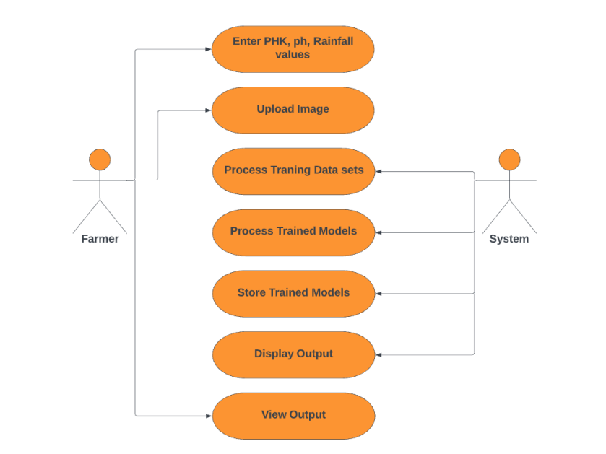

**7.Project-Screenshot**

**Home page:**

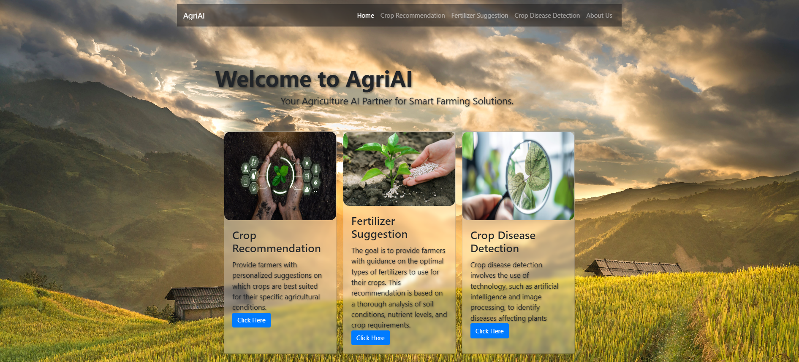

**Crop Prediction page:**

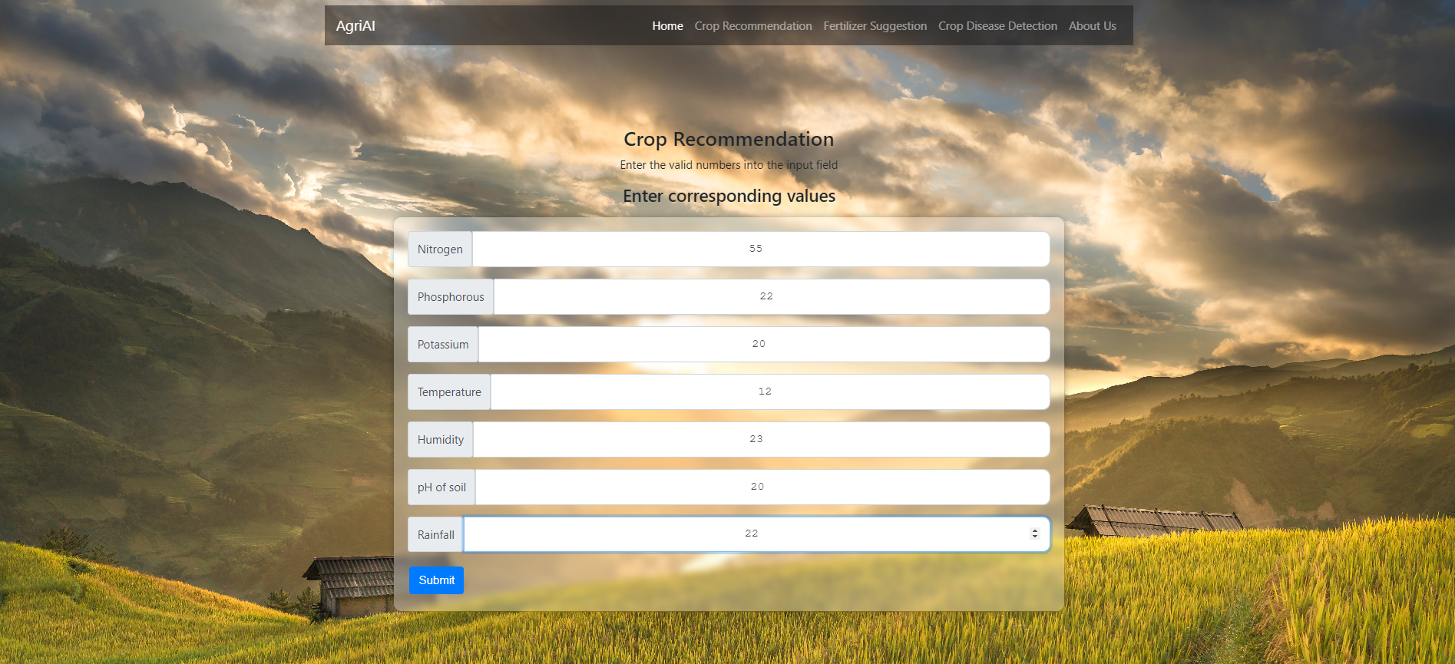

**Crop Prediction output page:**

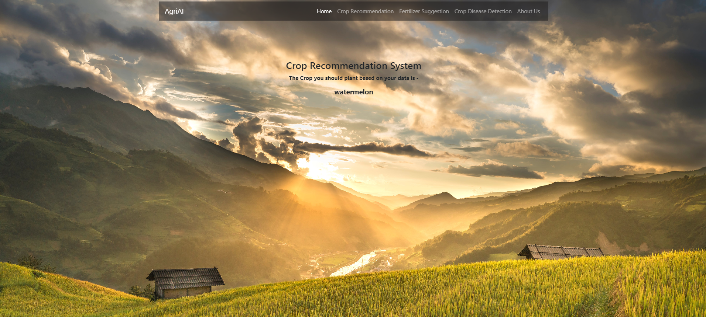

**Fertilizer Suggestions page:**

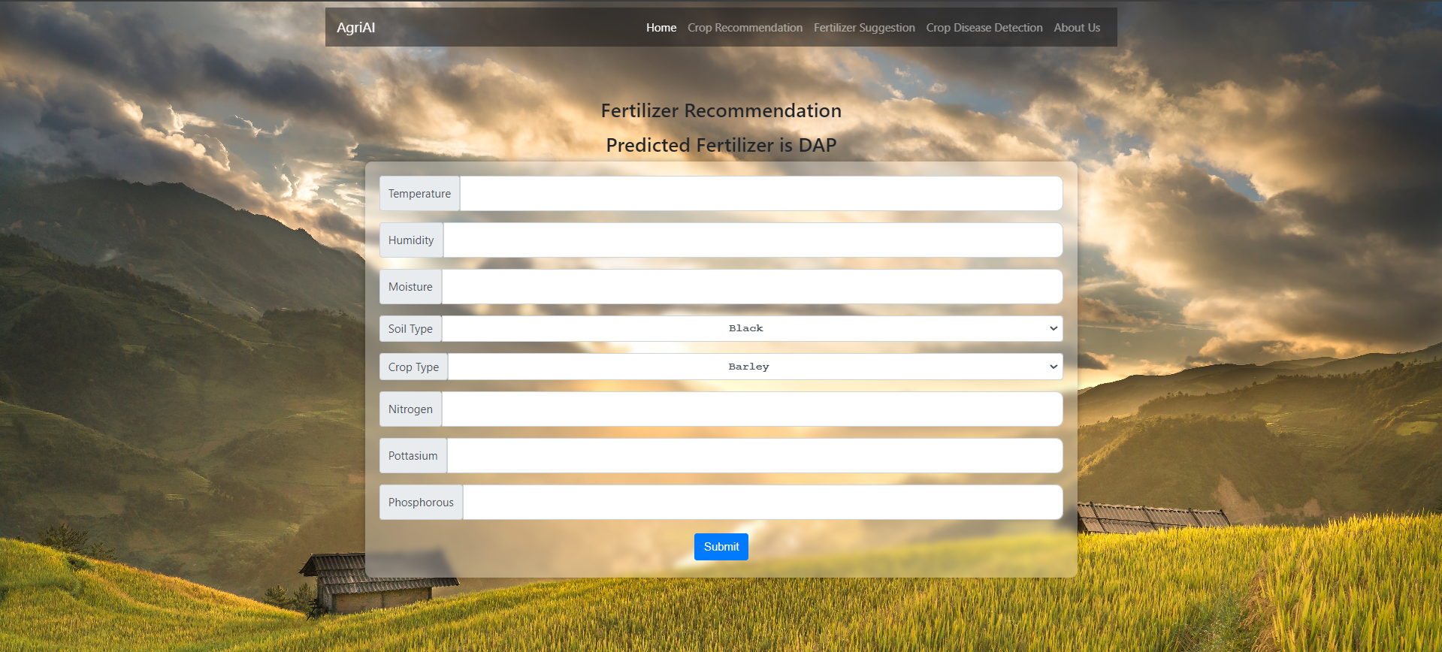

**Crop Disease Identification page:**



**Crop Disease Identification output page:**



**About Us page :**

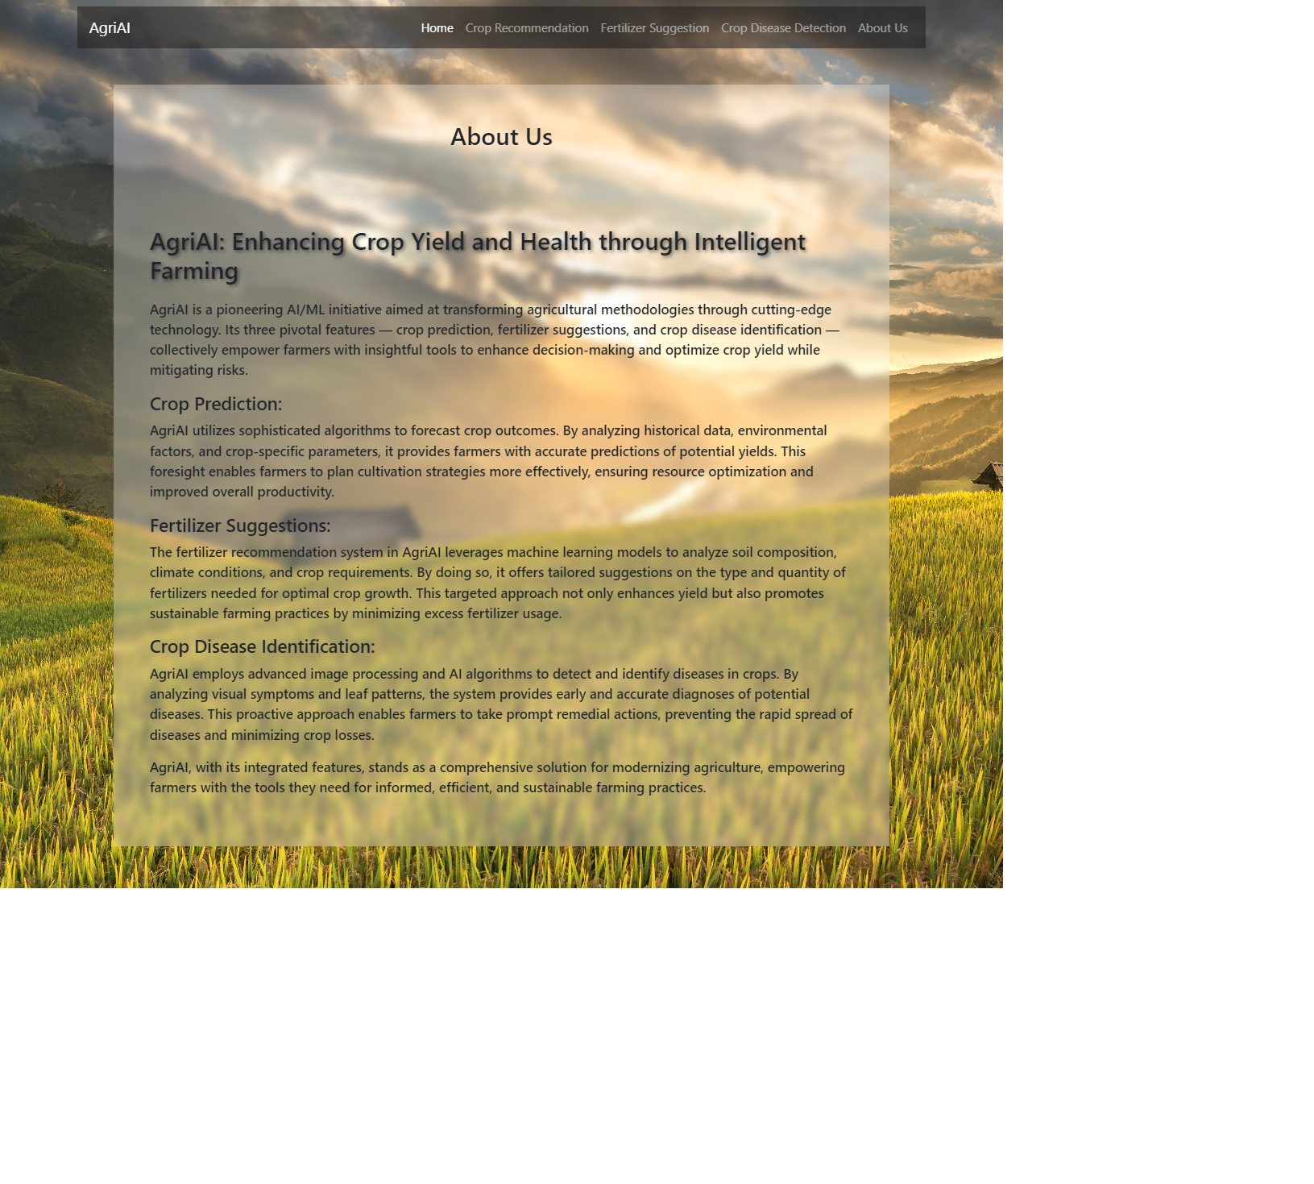

**8.Conclusion**

* In summary, AgriAI is like a superhero for farmers, changing the way they do farming. It uses really smart technology to help farmers with important things like knowing when to plant crops and how much they'll grow. The special thing about AgriAI is that it can give farmers personalized advice, quick updates on what's happening on the farm, and even help spot and fix crop diseases using pictures.
* AgriAI isn't just for one farmer; it's like a friend for farmers all around the world. It doesn't just make farming better for them, but also for people who help farmers, like those who provide advice, sell farming supplies, and protect the environment. AgriAI is a cool mix of technology and nature, making sure we have enough good food while taking care of our planet. It's not just a tool; it's a helper bringing positive changes to how we grow our food for a safer and healthier future.